Prisms Unit Study Guide
Test Date: _____________________

Students should understand the two acceptable formulas for finding volume:
v= l x w x h OR v= b x h

Students will find volume of regular prisms and irregular prisms

Students will solve for a missing dimension when given 2 dimensions and the total volume.

When given a box pattern, students will need to identify the area of the base as well as the volume of the box.

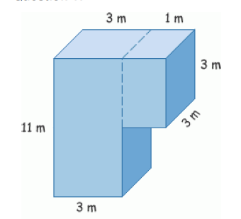
Try these out for practice:

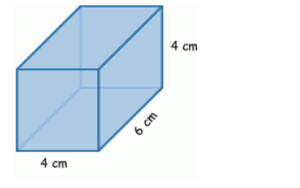

Find the volume: ________________________
Find the volume of this irregular prism: ____________________________

What is the volume of a box that is 12 inches long, 4 inches wide and 7 inches in height?

A box has a length of 8 inches, width of 9 inches and height of 10 inches. What is the area of the base?

The volume of this rectangular prism is 126 ${ft}^{3}$

3ft

?

7 ft Find the missing dimension _______________

How many cubes can fill the box made with this pattern?
